Figure 1: Six theoretical food web scenarios for bulk stable isotope modelling constructed from consumer experimental stable isotope half-life (*t0.5*) studies and observed nitrogen stable isotopes values of particulate organic matter (baselines 1-4; Table 2) from four distinct aquatic systems. Three comparisons were made between two food web scenarios: 1) different *t0.5* of the secondary consumer 2) different *t0.5* of the secondary and tertiary consumer 3) different baseline from particulate organic matter.

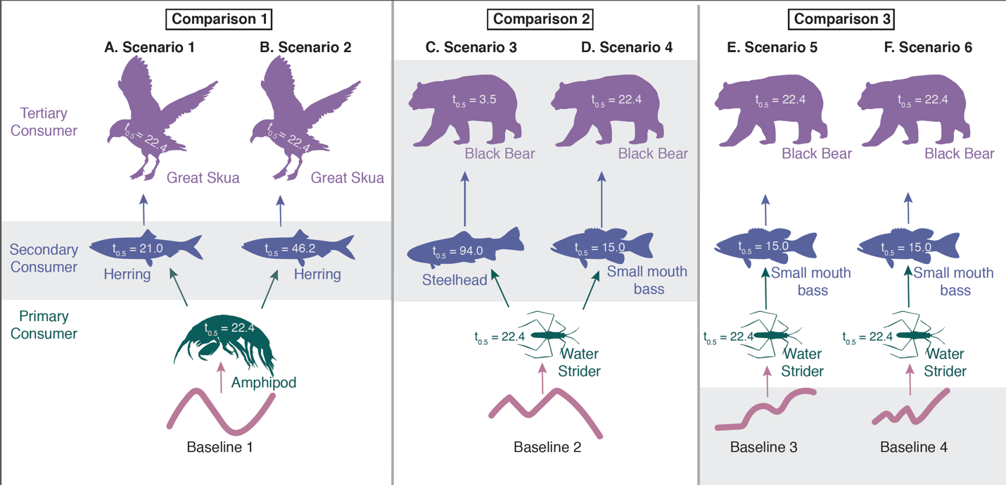

Figure 2: A theoretical food web for CSIA modelling constructed from consumer experimental stable isotope half-life (*t0.5*) studies and applied to observed nitrogen stable isotopes values of particulate organic matter from all four distinct aquatic systems (baselines 1- 4, Table 2).

Figure 3: Depiction of the two effect sizes used to assess accuracy of trophic position estimation in this study 1) the magnitude of trophic position deviation which describes the degree to which trophic position is over or under estimated and 2) the duration of deviation which describes the length of time over the course of the model simulation that trophic position was erroneously estimated by ± 0.2 trophic levels.



Figure 4: Simulated primary, secondary, and tertiary consumer bulk nitrogen stable isotope values (δ15N ) for six (A-F) food web scenarios (Figure 1) using δ15N of particulate organic matter from observational studies as the stable isotope baseline (Table 1).



Figure 5: Trophic position deviation based on simulated primary, secondary, and tertiary consumer bulk nitrogen stable isotope values (δ15N ) for six (A-F) food web scenarios (Figure 1) and three main comparisons using POM stable isotope values to calculate trophic position. 0 denotes the true trophic level of a given consumer and grey box denotes trophic position deviation of ± 0.2 trophic levels and used to calculate duration of deviation.

Figure 6: Simulated amino acid (color) nitrogen CSIA values (δ15N ) for primary (A, C, E, G) and secondary (B, D, F, H) consumers using four stable isotope baselines derived from observational particulate organic matter studies (Table 1, Figure 2).



Figure 7: Trophic position deviation from simulated amino acid (color) nitrogen CSIA values (δ15N ) for primary (A, C, E, G) and secondary (B, D, F, H) consumers using four stable isotope baselines derived from observational particulate organic matter studies (Table 1, Figure 2). 0 denotes the true trophic level of a given consumer and grey box denotes trophic position deviation of ± 0.2 trophic levels and used to calculate duration of deviation.



Figure 8: Sensitivity analysis of the magnitude of trophic position deviation from bulk stable isotope values in response to primary, secondary, and tertiary (color) consumer stable isotope half-life values for a single simulated stable isotope baseline (a). Solid line denotes mean magnitude of deviation across the 125-day baseline simulation (A) for a given half-life and shaded region denotes 1 standard deviation from the mean. 0, in B-D, represents the true trophic level of a consumer.

Figure 9: Sensitivity analysis of the magnitude of trophic position deviation from CSIA for primary, secondary, and tertiary (color) consumer stable isotope half-life values for a single simulated stable isotope baseline (a). The source amino acid line denotes the single half-life value (130 days, lysine tuna) of the source amino acid modelled in this analysis. Solid line denotes mean magnitude of deviation across the 125-day baseline simulation (A) for a given half-life and shaded region denotes 1 standard deviation from the mean. 0, in B-D, represents the true trophic level of a consumer.



Figure 10: Sensitivity analysis of the magnitude of trophic position deviation from CSIA for primary, secondary, and tertiary (color) consumer stable isotope half-life values for a single simulated stable isotope baseline (a). The source amino acid line denotes the single half-life value (33 days, phenylamine in shrimp) of the source amino acid modelled in this analysis. Solid line denotes mean magnitude of deviation across the 125-day baseline simulation (A) for a given half-life and shaded region denotes 1 standard deviation from the mean. 0, in B-D, represents the true trophic level of a consumer.



Figure 11: Nitrogen stable isotope half-life (days) values experimentally derived for a) bulk stable isotope analysis (Vander Zanden et al. 2015) for different species (label) and tissues (color) and b) CSIA of individual amino acids (Downs et al. and Popp et al.) for different species (color) and amino acids (label).



Figure 12: Trophic position deviation based on simulated primary, secondary, and tertiary consumer bulk nitrogen stable isotope values (δ15N ) for six (A-F) food web scenarios (Figure 1) using the primary consumer stable isotope values to calculate trophic position. 0 denotes the true trophic level of a given consumer and grey box denotes trophic position deviation of ± 0.2 trophic levels and used to calculate duration of deviation.



Table 1: Summary of observational nitrogen stable isotope baseline data used for modelling case studies.

|  |  |  |  |  |  |  |
| --- | --- | --- | --- | --- | --- | --- |
| *Study* | *Taxa* | *Season of Data* | *Range of Isotopic Change* | *Ecosystem* | *Location* |  |
| **1.** Wu et al. 1999 | POM | January - December 1989 | 4.11 | Marine upwelling zone | Coast of Vancouver Island, Canada |  |
| **2.** Gu et al. 1994 | POM | January - December 1989 | 4.20 | Eutrophic, subartic lake | Smith Lake, Fairbanks, Alaska, USA |  |
| **3.** Syvaranta et al. 2008 | POM | May - September 2004 | 5.68 | Moderately eutrophic, urban lake | Jyväsjärvi Lake, Jyväskylä, Finland |  |
| **4.** Matthews and Mazumder 2007 | POM | February 2002 - April 2003 | 10.40 | Pristine oligotrophic lake | Council Lake, Vancouver Island, Canada |  |

Table 2: Duration of trophic position deviation (number of days the magnitude of trophic position deviation ± 0.2 trophic levels from the true value) for each of the of the six, bulk stable isotope food web scenarios (Figure 1).

|  |  |  |  |  |  |  |
| --- | --- | --- | --- | --- | --- | --- |
| Duration of Trophic Position Deviation (days) | | | | | | |
|  | Scenario 1  (*365*) | Scenario 2  (*365*) | Scenario 3  (*365*) | Scenario 4  (*365*) | Scenario 5  (*233*) | Scenario 6  (*351*) |
| Primary Consumer | 129 (35%) | 129 (35%) | 85 (23%) | 85 (23%) | 51 (21%) | 53 (15%) |
| Secondary Consumer | 197 (54%) | 194 (53%) | 261(71%) | 221 (60%) | 92 (40%) | 73 (21%) |
| Tertiary Consumer | 211 (57%) | 226 (62%) | 274 (75%) | 220 (60%) | 162 (70%) | 143 (40%) |

Table 3: Duration of trophic position deviation (number of days the magnitude of trophic position deviation ± 0.1 trophic levels from the true value) for each of the of the two CSIA food web scenarios (Figure 2).

|  |  |  |  |  |
| --- | --- | --- | --- | --- |
| Duration of Trophic Position Deviation (days) | | | | |
|  | Baseline 1  (*365*) | Baseline 2  (*365*) | Baseline 3  (*233*) | Baseline 4  (*351*) |
| *Shrimp (primary consumer)* | | | | |
| Glutamic Acid | 0 | 0 | 0 | 0 |
| Alanine | 0 | 0 | 0 | 0 |
| Proline | 46 | 67 | 125 | 32 |
| Valine | 0 | 0 | 0 | 7 |
| *Tuna (secondary consumer)* | | | | |
| Glutamic Acid | 0 | 0 | 75 | 0 |
| Alanine | 0 | 0 | 72 | 0 |
| Proline | 109 | 90 | 147 | 13 |
| Valine | 100 | 73 | 127 | 43 |

Table 4: Trophic position estimates applying a 90-day lag between baseline sampling and consumer sampling

|  |  |  |  |
| --- | --- | --- | --- |
| 1. Range of trophic position estimates using POM as the stable isotope baseline | | | |
|  | Primary Consumer  TL = 2 | Secondary Consumer  TL = 3 | Tertiary Consumer  TL = 4 |
| Scenario 1 | 1.4 – 2.4 | 2.6 – 3.3 | 3.8 – 4.2 |
| Scenario 2 | 1.4 – 2.4 | 2.8 – 3.2 | 3.9 – 4.4 |
| Scenario 3 | 0.8 – 2.9 | 2.2 – 3.6 | 3.2 – 4.6 |
| Scenario 4 | 0.8 – 2.9 | 2.1 – 3.9 | 3.4 – 4.7 |
| Scenario 5 | 2 – 3.1 | 3.0 – 3.8 | 3.9 – 4.4 |
| Scenario 6 | 1.9 – 4.0 | 2.9 – 3.9 | 3.9 – 4.2 |
| 1. Range of trophic position estimates using the primary consumer as the stable isotope baseline and applying | | | |
| Scenario 1 | – | 2.5 – 3.4 | 3.7 – 4.3 |
| Scenario 2 | – | 2.7 – 3.3 | 3.8 – 4.2 |
| Scenario 3 | – | 2.5 – 3.4 | 3.5 – 4.3 |
| Scenario 4 | – | 2.4 – 3.6 | 3.7 – 4.5 |
| Scenario 5 | – | 3.1 – 4.1 | 4.0 – 4.7 |
| Scenario 6 | – | 2.9 – 4.0 | 3.9 – 4.3 |